# Introduction

Analysis has always been the most important part in the software or system development. It is the first and the foremost step during the development process. Even in the waterfall model of development methodology, ‘Analysis and Requirements Gathering’ is the first stage. Here in this stage, the project is analyzed to explore the requirements that need to be fulfilled by the system when it is developed. Those requirements which a client or user requires from the system. Those requirements which a developer must keep in mind during the further phases of the system development such as design and development phase. These requirements will be separated as functional and non-functional. Use case diagrams are produced to provide functional overview of the system describing how user interacts with different parts of the system. Now, based upon the requirements and use cases, an architecture of the proposed system will be designed called ‘System Architecture’. Initial class diagram will also be produced to support the design of system architecture.

So here in my case, I am going to perform analysis specification for my ***Cars Game*** project. First of all, requirements (functional and non-functional) will be understood and gathered. MoSCoW prioritization technique will be used to prioritize the requirements. Now, on the basis of specified requirements, use case diagram will be produced which may be one or more. Each interaction presented in the diagram will be described briefly one by one just after the diagram. Then, our final section will be the system architecture where a proposed system is modeled by drawing initial class diagram. This architecture provides initial design of the proposed system which may not include elements that will be added during the design and development stage of our development process.

# 3)Use cases

Use case diagram is an important part in managing your abstractions. It is an UML (Unified Modeling Language) diagram used to represent the broad interactions between different parts of a system. Use case also represents a set of functionalities that must be supported for each part. Those parts are called actors and they may be users or subsystems. Use case is typically used for scenario description. It is designed for the better understanding of the system functionalities. It clearly represents the main activities involved in the system allowing a developer to easily design the system in later stages of development process. They are also really helpful for a developer to present the overview of system functionalities to the clients.

Before diagramming use cases, use case analysis is performed. Use case analysis is an important and valuable requirement analysis technique that has been widely used in modern software engineering. Identification of actors and their use cases on the system is the major activity before preparing use cases. Associations are made between the actors and use cases but not between the actors. It is an UML diagram which is drawn using UML designing tool such as StarUML or Visual Paradigm. For my project, I have decided to use StarUML tool to draw use cases. The use case diagrams were drawn for the ***Cars Game*** in StarUML and they are presented here below: -

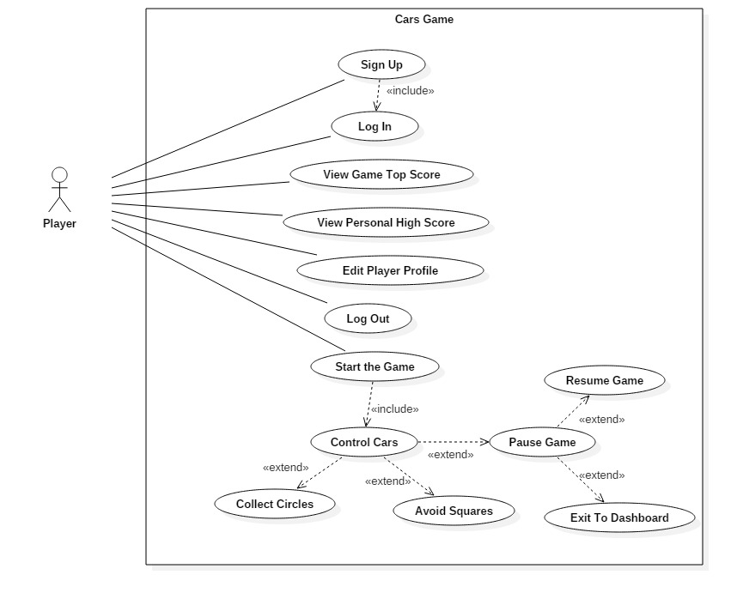

*Diagram (1): Use case diagram 1*

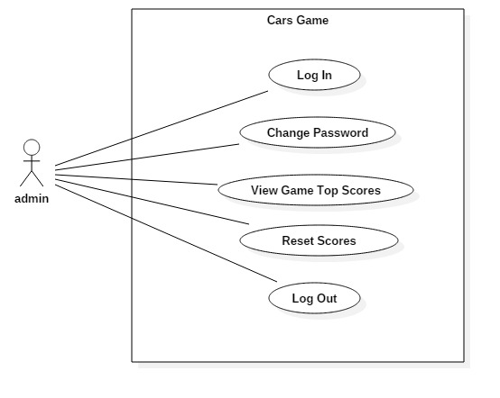

*Diagram (2): Use case diagram 2*

Use case scenario description for the ‘Sign up’ from diagram 1 is as follows: -

* Player opens up the sign up/registration form.
* Player fills his/her personal and login credentials such as name, password, address, etc.
* Player clicks the ‘sign up’ button.
* Validation is performed by the system if the form is filled properly.
* The system checks to see if the player already exits in the system.
* The system creates a player with the provided information.
* If registration or sign up is successful, appropriate message is provided by the system.
* If sign up is not successful, the system notifies the player and redirects him/her to the sign-up form.

Use case scenario description for the ‘Log In’ from diagram 1 is as follows: -

* Player opens up the login form.
* Player enters his/her login credentials in the form.
* Player clicks the ‘Log In’ button.
* The system compares the login details provided with the details stored in database.
* If logging in is successful, success message is provided and the player is directed to the dashboard panel.
* If logging in is unsuccessful, appropriate message is provided by the system and the player is redirected to the login form.

Use case scenario description for the ‘View Game Top Score’ from diagram 1 is as follows: -

* Player logins with the system to open up dashboard panel.
* Player clicks the ‘View Top Score’ button to see the highest score in the game so far along with the scorer name.
* The score is retrieved from the database.

Use case scenario description for the ‘View Personal High Score’ from diagram 1 is as follows: -

* After logging in with the game, the player clicks ‘View My High Score’ button from the dashboard to view the highest score he/she has achieved so far in the game.
* The score is retrieved from the database.

Use case scenario description for the ‘Edit Player Profile’ from diagram 1 is as follows: -

* Player clicks ‘Edit Player Profile’ button from dashboard to open up ‘Edit Profile’ form.
* The form is pre-filled with the player information retrieved from database by the system.
* The player edits the details in the form and clicks the ‘Update’ button.
* If update is successful, the system notifies the player.
* If update is unsuccessful, appropriate message is provided to the player and redirected to the form again.

Use case scenario description for the ‘Log Out’ from diagram 1 is as follows: -

* Player clicks ‘Log Out’ button from the dashboard panel to log out from the system.
* Player is directed to login form.

Use case scenario description for the ‘Start the Game’ from diagram 1 is as follows: -

* Player clicks ‘Start the Game’ button from the dashboard after logging in with the system to open the main game panel.
* Player is directed to the game panel and the game time starts
* The game panel consists of two tracks with one car for each track. One car will be colored red and another blue.
* Each track has two lanes.
* Game panel also shows the game running time and score which increases continuously till the game continues.

Use case scenario description for the ‘Control Cars’ from diagram 1 is as follows: -

* Player uses ‘Left-Arrow’ and ‘Right-Arrow’ keys at the same time from keyboard to control two cars at the same time.
* ‘Left-Arrow’ key changes lane of the first car in the first track.
* ‘Right-Arrow’ key changes lane of the second car in the second track.

Use case scenario description for the ‘Collect Circles’ from diagram 1 is as follows: -

* After starting the game, a player controls the cars to change lanes of the tracks to collect circles on the track.
* Circles appear randomly on the tracks which require a player to collect these by colliding cars with the circles.
* If player fails to collect any one of the circles, the game will be over and the player is directed to scoreboard from the game panel.
* Player continuously collects circles till the game continues.
* Score increases continuously until the game is over.
* More longer a player collects circles, more score he/she will achieve.

Use case scenario description for the ‘Avoid Squares’ from diagram 1 is as follows: -

* During the game, player controls the cars using keystrokes to change lanes on the track.
* Player changes lanes to avoid squares on the track.
* Squares appear randomly on the tracks.
* Player needs to protect cars from collision with the squares.
* If any car collides with the squares, the game is over and the player is directed to scoreboard from the game panel.
* More longer a player avoids squares, more longer the game continues and more score he/she will achieve.

Use case scenario description for the ‘Pause Game’ from diagram 1 is as follows: -

* While playing the game, a player can pause the game through ‘P’ keystroke from keyboard or ‘Pause’ button on the game panel.
* All the moving objects including game time and score stops which can later be resumed again.

Use case scenario description for the ‘Resume Game’ from diagram 1 is as follows: -

* After game has been paused, player has option to resume it by just clicking ‘Resume’ option from the game panel.
* Game time, score and objects on the screen continue from where they have been paused.

Use case scenario description for the ‘Exit to Dashboard’ from diagram 1 is as follows: -

* After game has been paused, player has option to exit from the game and return to dashboard.
* Player exits from the game by just clicking ‘Exit to Dashboard’ option on the game panel.

Use case scenario description for the ‘Log In’ from diagram 2 is as follows: -

* Administrator opens up the login form.
* Admin enters his/her login credentials in the form.
* Admin clicks the ‘Log In’ button.
* The system compares the login details provided with the details stored in database.
* If logging in is successful, success message is provided and the admin is directed to the admin dashboard panel.
* If logging in is unsuccessful, appropriate message is provided by the system and the admin is redirected to the login form again.

Use case scenario description for the ‘Change Password’ from diagram 2 is as follows: -

* Administrator opens up a form to change password by clicking ‘Change Password’ option from admin dashboard.
* Admin enters his/her new password for login.
* Admin clicks ‘Change’ button on the form.
* If password is changed successfully, admin is notified by the system.
* If password is not changed successfully, appropriate message is provided by the system and he/she is redirected to the form.

Use case scenario description for the ‘View Top Scores’ from diagram 2 is as follows: -

* Administrator clicks ‘View Top Scores’ option from dashboard to open up score table.
* The table displays top scores of the game with scorer name.
* Scores are listed in descending order with the highest score at the top decreasing continuously as we go down.

Use case scenario description for the ‘Reset Scores’ from diagram 2 is as follows: -

* Administrator clicks ‘Reset Scores’ option from dashboard to reset all the scores scored so far in the game.
* This deletes all score records from database along with the highest score of the game.
* Game is reset to new state with no score records.

Use case scenario description for the ‘Log Out’ from diagram 2 is as follows: -

* Administrator clicks ‘Log Out’ button from the dashboard panel to log out from the system.
* Admin is directed to login form.